Question 1:

Question 2:

Question 3:

Question 4:

Question 5:

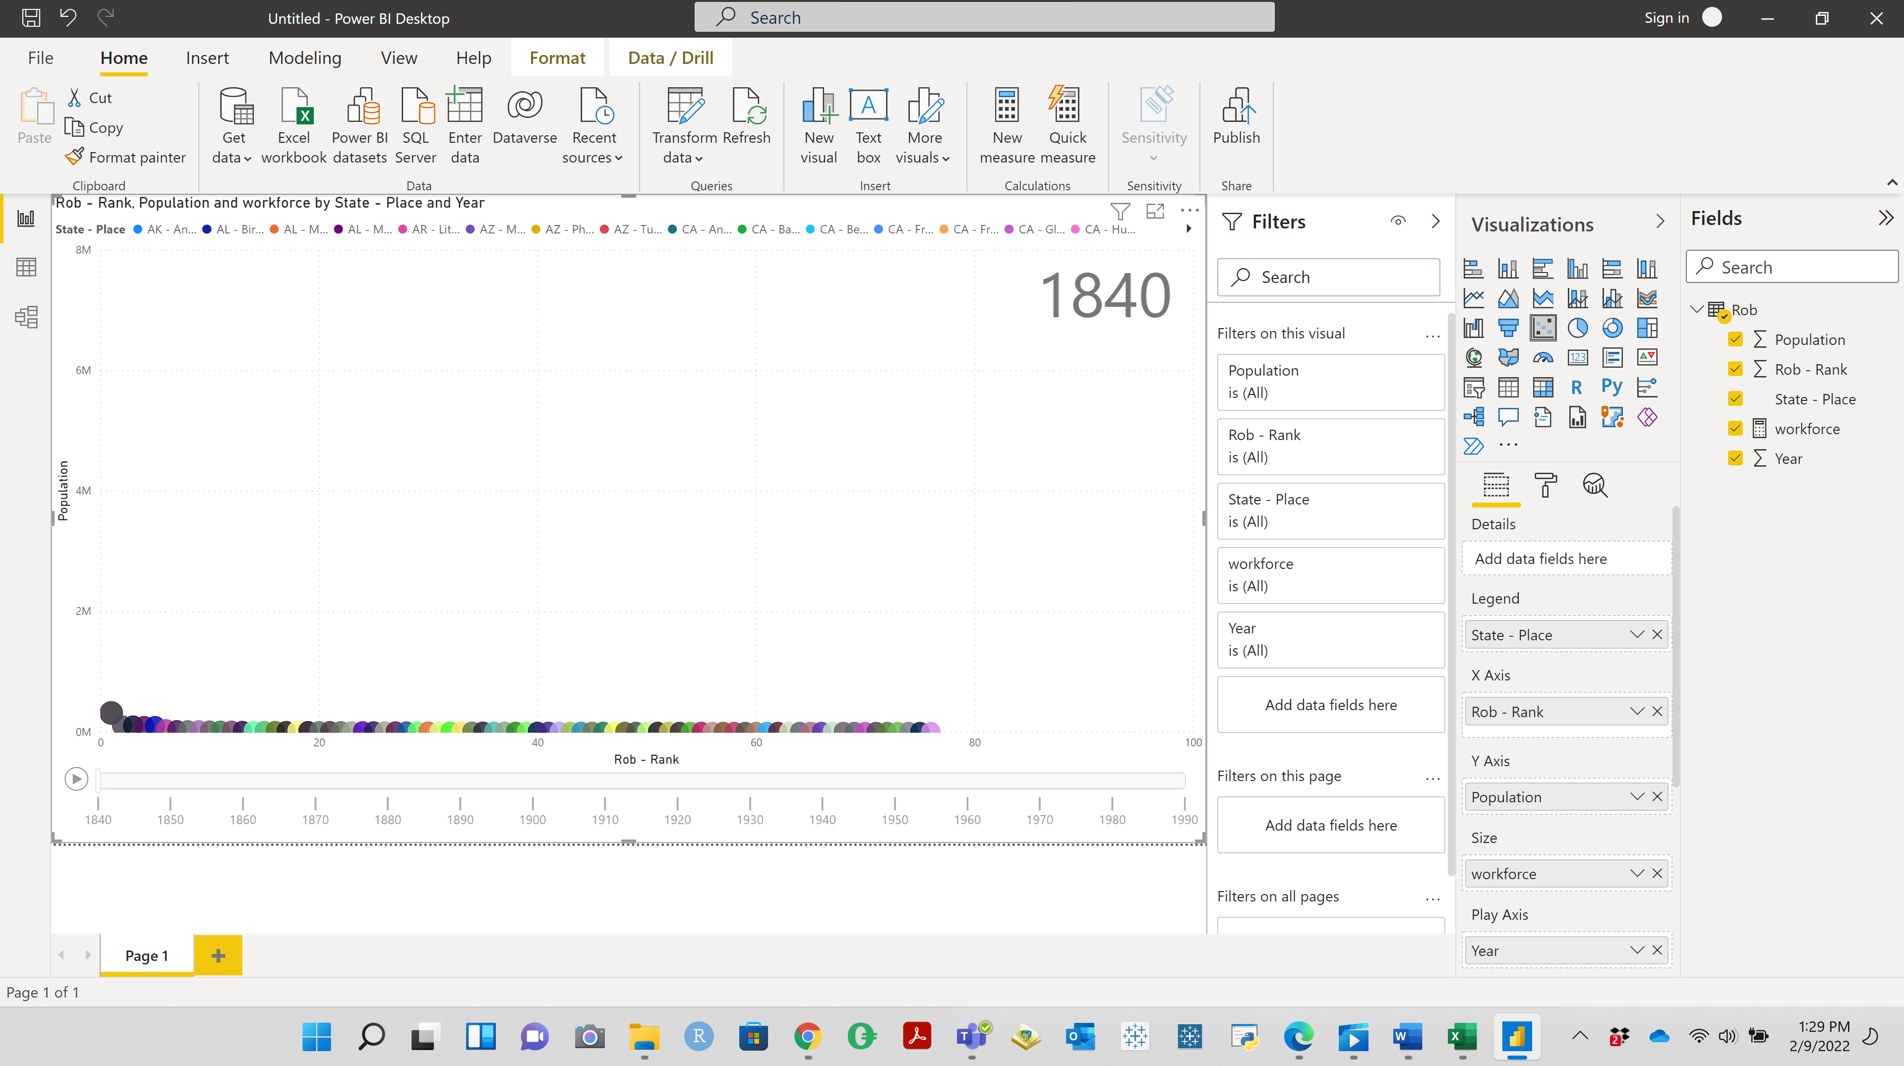

Question 6:

